Abstract Title

N. Surname¹, N. Surname², N. Surname^{1,2}
¹Department, Institution/Company, City, Country
²Department, Institution/Company, City, Country
email address

The abstract must be written in English and its length must be of two pages: the first page for text and references (approximately 500 words), the second page for figures and tables. The two-page abstract must synthetically describe the objectives, methods and results of the work.
An example image is shown in Fig. 1. If necessary, relevant equations can be included in the abstract.
(1)
Equations and reference citations must be numbered as (1) and [1], respectively. Figures and tables must be placed in the second page.
For the abstract preparation, please respect the following format specifications according to this document template. Page: A4, left, right, top and bottom margins 2,5cm. Title: 22pt, Times New Roman. Authors and affiliations: 11pt, Times New Roman. Text: 12pt, Times New Roman. Space between text paragraphs: 6pt. Captions of Figures and Tables: 10pt Times New Roman. References: 10pt, Times New Roman. Do not number pages.
The abstract submission deadline is May 13th (Monday), 2019 at 23.59 GMT+1. The notification of acceptance is scheduled on June 7th (Friday), 2019. For any questions feel free to contact the SIE2019 organizing committee by email info@sie-2019.uniroma2.it.
When submitting their abstract as a PDF file, through the Easy Chair online system, the Authors must select one specific SIE scientific area among those reported in Table 1. For the submission, Authors can follow the link provided on the SIE2019 web site http://sie-2019.uniroma2.it/authors/call-for-papers/ Abstract submissions via email cannot be accepted.

References

[1] N. Surname et al., “Title of the Paper”, Journal/Transaction Name, vol. xx, n. x, year, pp. Xx-xx.
[2] N. Surname et al., “Title of the Paper”, Proc. of Conference Name or Acronym, year, pp. xx-xx.
[3] N. Surname et al., “Title of the Chapter in a Book”, in Title of the Book, publishing house, year, pp. xx-xx.
[4] N. Surname et al., Title of the Book, publisher, year.

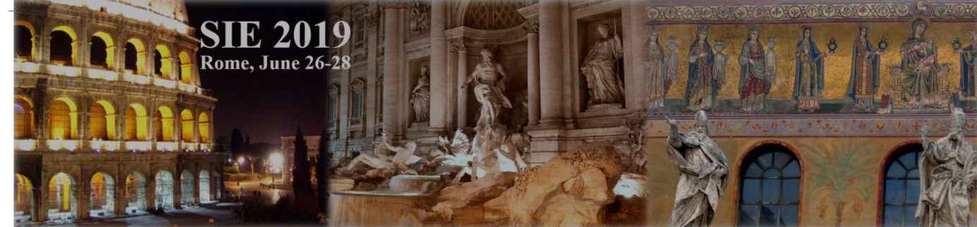
Figure 1: SIE2019 banner.

Area | Title | Area coordinator
Area 1 | Integrated Circuits and Systems  (Sistemi elettronici integrati) | Prof. Salvatore Pennisi
Area 2 | Micro- and Nano-Electronic Devices  (Dispositivi micro e nano elettronici) | Prof. Fernanda Irrera
Area 3 | Microwave Electronics  (Elettronica delle microonde ed onde millimetriche) | Prof. Giorgio Vannini
Area 4 | Sensors, Microsystems and Instrumentation  (Sensori, microsistemi e strumentazione) | Prof. Giuseppe Ferri
Area 5 | Optoelectronics and Photonics  (Optoelettronica e fotonica) | Prof. Luigi Zeni
Area 6 | Power Electronics  (Elettronica di potenza e applicazioni industriali) | Prof. Giorgio Spiazzi
Area 7 | Electronic Systems and Applications  (Sistemi elettronici e applicazioni) | Prof. Sergio Saponara
Table 1: SIE Scientific Areas

